
Decoding the AI Market: Key Players, Growth Trends, and Stocks to Watch
Emerging AI 2.0 Stocks to Watch
Author: Montecito Capital Management
Date: November 10, 2025
The artificial-intelligence sector feels noticeably calmer than it did during the height of the recent boom. After months of enthusiasm surrounding anything tied to AI, many of the biggest tech names have finally cooled off, taking some of the froth out of valuations. Across the broader AI build-out, a wide range of companies are down roughly 30% from their 52-week highs. Even the largest members of the Magnificent Eight have lost some altitude: Meta remains about 16% off its all-time high, and Nvidia — despite a solid rebound — had previously shed more than a third of its value from its peak. A handful of other AI-driven leaders have also seen meaningful double-digit declines, signaling a clear shift away from the euphoric pricing that dominated the earlier phase of the cycle.
This backdrop sets the stage for what many analysts are calling “AI 2.0,” a period defined by rapid innovation, broader real-world adoption, and a new class of emerging leaders who could reshape the technology landscape in far more practical ways than the initial wave of hype suggested. The next leg of AI growth reaches well beyond headline applications; it encompasses the foundational components — cloud infrastructure, model-training platforms, semiconductor ecosystems — as well as highly specialized uses in sectors like healthcare, finance, manufacturing, and scientific research.
For investors, that combination of a healthier valuation landscape and a sector entering its next phase creates a more balanced opportunity. Instead of chasing momentum, this is a moment to understand the deeper structure of the AI ecosystem: which companies truly have scalable technology, which have built durable partnerships, and which are best positioned as AI becomes embedded in everyday business processes.
As AI continues to mature through 2025, the focus shifts toward evaluating valuation multiples, comparing performance trends from 2024 to 2025, and reviewing how analyst expectations for 2025–2026 align with the actual trajectory of the industry. With many leaders undergoing a reset while long-term demand remains strong, this period offers room for investors to build exposure gradually — targeting places where innovation, durability, and more reasonable entry points intersect.
From here, we’ll break down the AI landscape by tiers, review key valuation metrics, and highlight the companies that appear best positioned to define the AI 2.0 era.
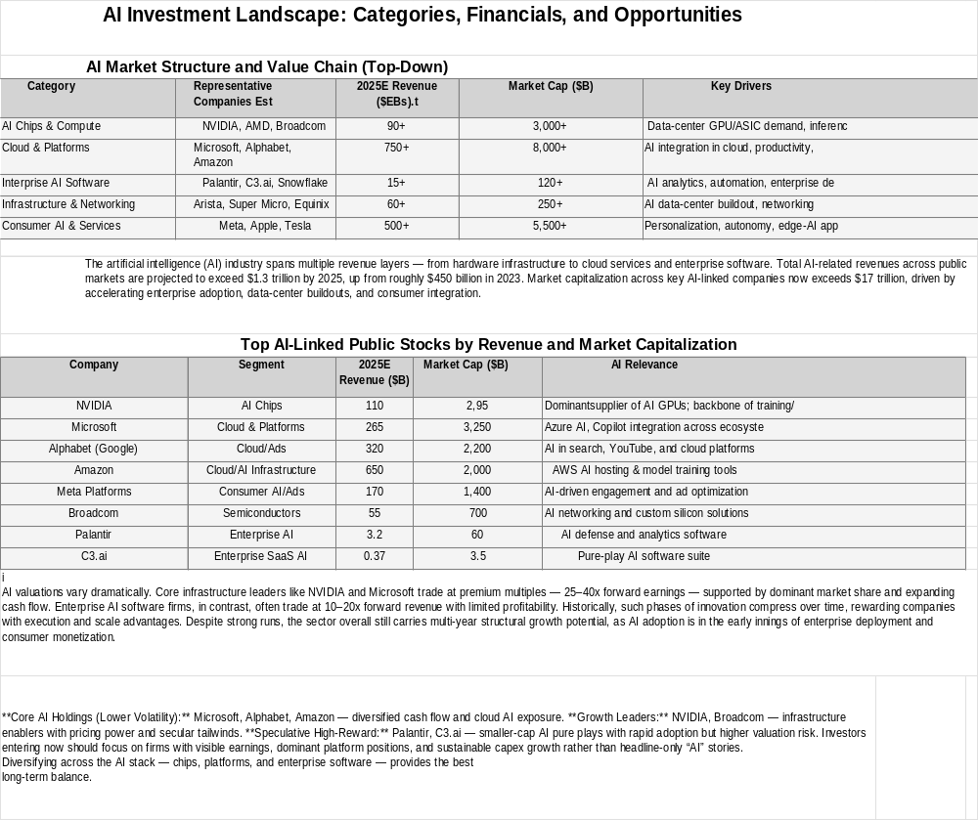
Analysts expect the next leg of AI growth to come from these areas:
- Edge AI — Bringing AI to devices, vehicles, and factories for real-time processing.
- AI Infrastructure — Data centers, networking, and power systems built to handle AI workloads.
- Enterprise Automation — Businesses using AI to cut costs and improve efficiency.
- Healthcare & Biotech AI — Accelerating drug discovery and diagnostics.
- Cybersecurity AI — Using machine learning to detect threats faster than humans.

AI Stock Categories, Market Leaders and Valuations
Primary AI Stocks (Market Leaders with Strong Earnings and Growth):
- NVIDIA (NVDA): Market cap exceeds $3 trillion, P/E about 59, with quarterly AI data center revenue surpassing $30 billion. NVIDIA's earnings growth has been above 90% annually, making it a cornerstone AI investment.
- Microsoft (MSFT): Market cap over $2.5 trillion, P/E ~34, Azure AI segment growing 30-40% annually, significant contributor to revenue.
- Alphabet (GOOGL): P/E about 27, with AI-enhanced search and cloud generating steady revenue and profit growth near 20%.
- Amazon (AMZN): P/E around 35, AWS leading in AI cloud infrastructure with roughly $750 billion segment revenue and 30% growth rate.
- Meta Platforms (META): P/E ~26, with AI integration powering social media and VR platforms, revenues over $500 billion.
Secondary AI Stocks (Specialists and High-Growth Names):
- AMD (AMD): P/E about 156, rapid revenue gains fueled by advances in AI-capable processors.
- Broadcom (AVGO): P/E ~92, major supplier of AI-optimized chips and network infrastructure.
- Palantir (PLTR): P/E ~85, with a $2.4 billion sales backlog and fast revenue growth driven by government and enterprise AI contracts.
- ServiceNow (NOW): P/E ~110, offering AI-driven workflow automation software.
- Snowflake (SNOW): Growing cloud data and AI services platform, with revenue surging over 40% annually.
Tertiary AI Stocks (Speculative and Niche Plays):
- Super Micro (SMCI): AI-focused hardware servers with volatile valuations.
- Intuitive Surgical (ISRG): P/E ~62, leveraging AI in robotic surgery.
- Lam Research (LRCX): Semiconductor equipment for AI chips, P/E ~33.
- Micron Technology (MU): Memory for AI workloads, P/E ~14.
- Taiwan Semiconductor (TSM): Foundry for AI chips, P/E ~32.
- Other notable high performers: Quantum Computing Inc. (QUBT) surged over 1100% in 2024.
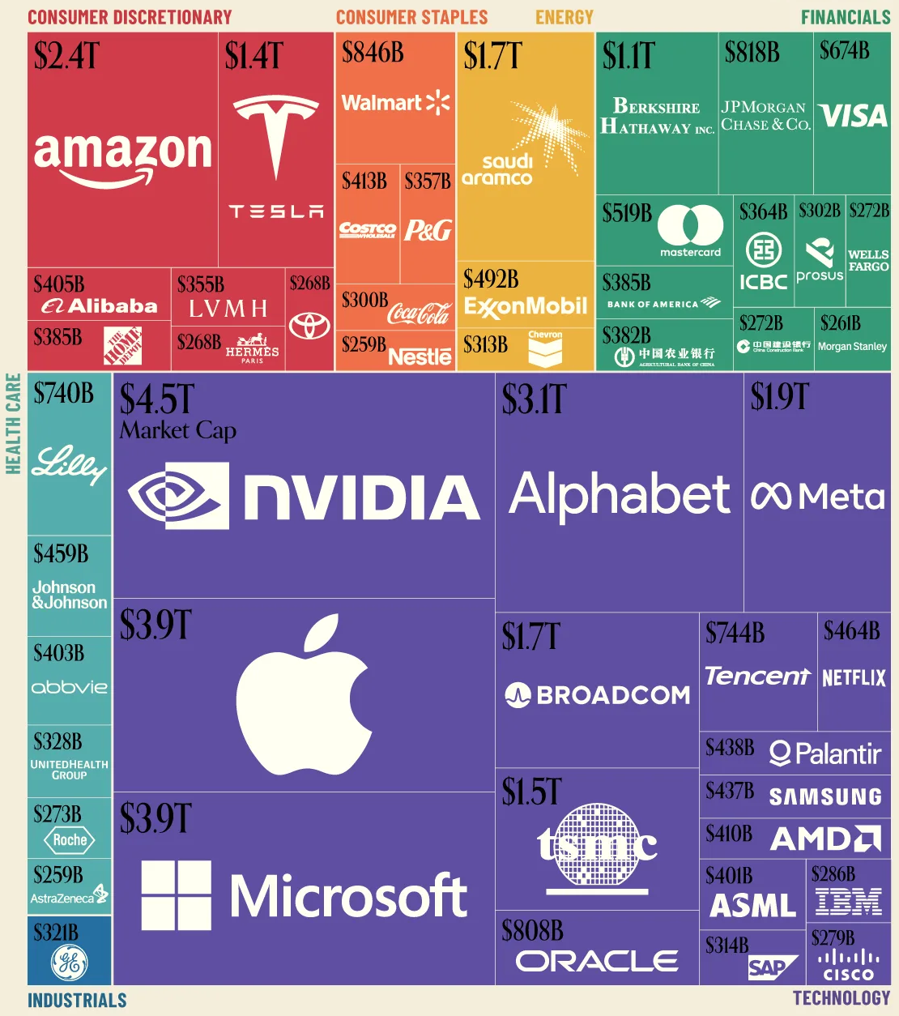

Market Performance: 2024 and Year-to-Date 2025
- The AI-INDEX, a market cap-weighted benchmark of AI-related stocks, rose approximately 61% in 2024, significantly outperforming the Nasdaq Composite (38%) and Dow Jones Industrial (16%).
- AI stocks overall saw large gains in 2024, with leaders like Palantir increasing over 370%, while many smaller players posted gains from 100% to over 200%.
- Year-to-date in 2025, many AI stocks continue strong performance in a volatile market, with some large-cap names up 15-30% in the first three quarters, supported by solid AI adoption and earnings growth forecasts.
- ETFs focusing on AI and big data report average P/E ratios in the high 30s to 40s, reflecting growth investor enthusiasm tempered by profit expectations.
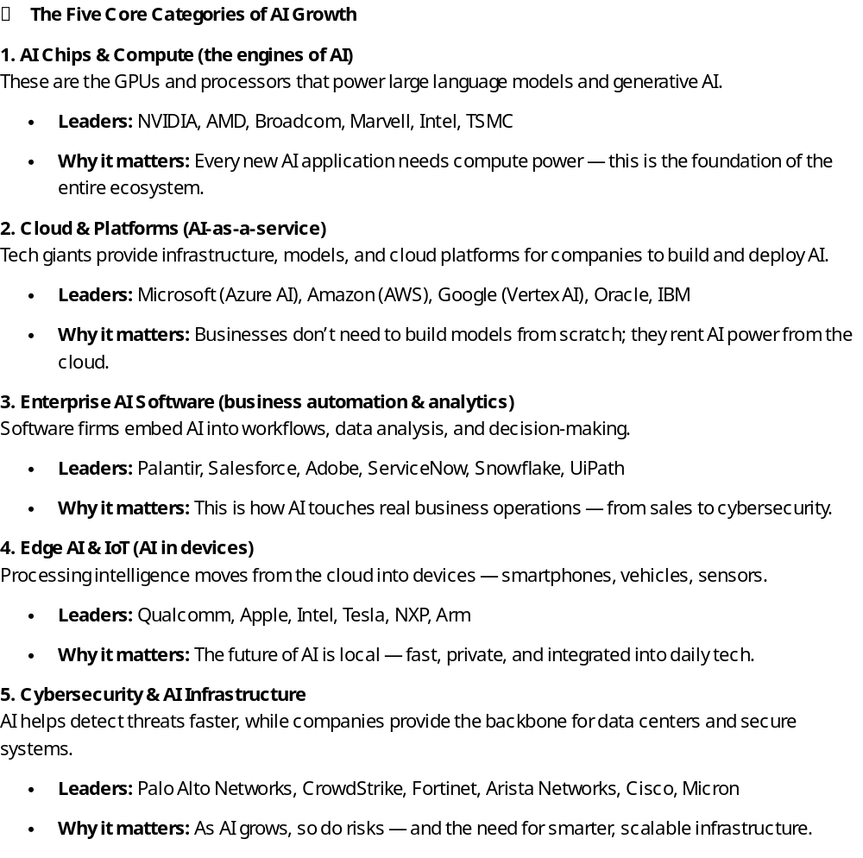
📊 Revenues & Market Caps by AI Category (approximate 2025 data)
Category | Example Companies | Combined Est. Annual Revenue | Typical Market Cap Range
AI Chips & Compute | NVIDIA, AMD, TSMC, Intel | $300–400B | $5T–$8T total
Cloud & Platforms | Microsoft, Amazon, Google | $700–900B | $9T–$10T total
Enterprise AI Software | Palantir, Adobe, Salesforce | $80–120B | $600–800B total
Edge AI & IoT | Qualcomm, Apple, Tesla | $500–600B | $7T–$9T total
Cybersecurity &  Infrastructure | Palo Alto, CrowdStrike, Cisco | $100–150B | $800B–$1.2T total

💡 Are AI Stocks Overvalued?
Yes and no. Some stocks — like NVIDIA or Palantir — trade at extremely high multiples of sales and earnings, pricing in years of future growth. That means even great earnings can lead to short-term pullbacks.
However, broader AI adoption is still early. Many traditional companies are only beginning to integrate AI into their operations. Investors with a 3–5 year horizon could still see strong compounding returns, especially in segments that haven’t fully priced in AI’s impact (edge devices, cybersecurity, and AI infrastructure).

🕒 Is It Too Late to Invest?
It’s not too late — but it’s not “early” either.
Think of 2023–2024 as the first wave of AI investing (training models, building chips).
Now we’re entering the second wave — applying AI across industries. That’s where opportunity shifts from just “who builds AI” to “who uses it best.”

💵 If Investing Now — Where to Look for mainstream AI stocks
Here are six leading names across the five categories, representing both growth potential and scale:
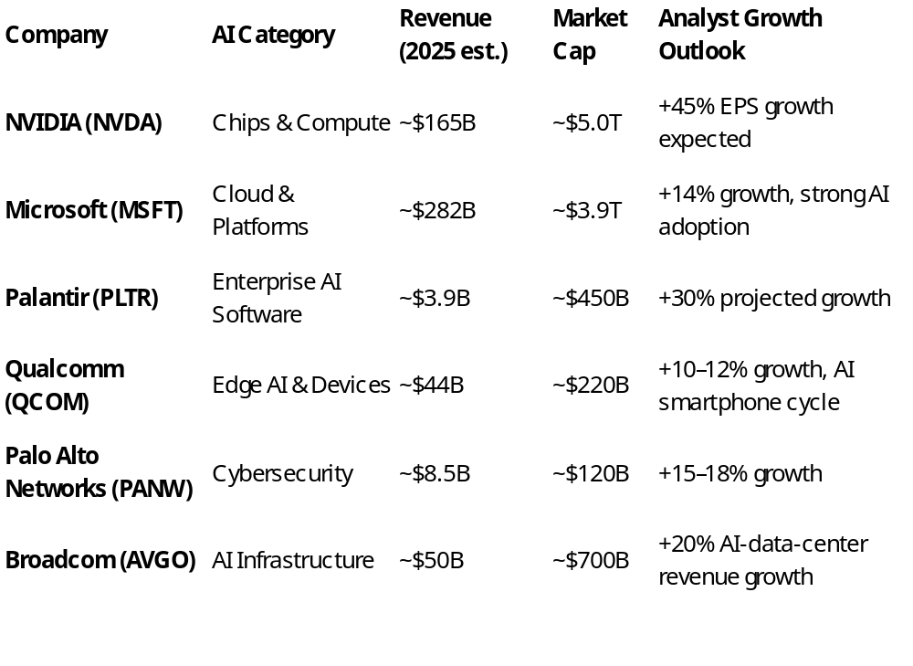
Analyst Forecasts for 2025-2026
- Corporate AI investment is expected to grow over 20% annually through at least 2026, driving expanding revenues across chips, cloud, software, and services.
- NVIDIA analysts project revenues surpassing $100 billion by 2026, driven by AI data center demand, with sustained high earnings growth.
- Microsoft and Alphabet expect AI-related revenue growth rates of 30-40% for several years, further expanding their cloud and software dominance.
- Secondary and tertiary tier firms like Palantir, Snowflake, and AMD are forecast to sustain 20-40% top-line growth as AI adoption deepens across industries such as healthcare, finance, and manufacturing.
- The AI sector overall is projected to continue outperforming broader tech, but with increasing differentiation between mature giants and higher-risk growth companies.

Emerging AI 2.0 Stocks to Watch

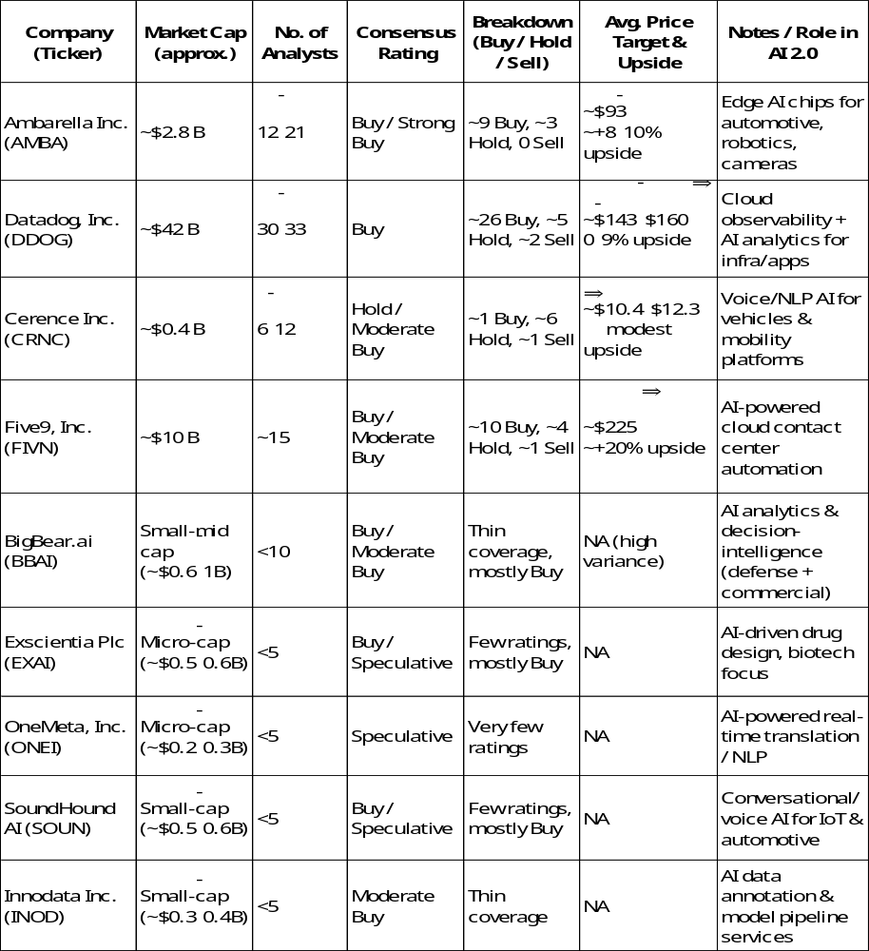

Summary / Key Takeaways
- Strong analyst sentiment: AMBA, DDOG, and FIVN have the strongest coverage and Buy ratings — making them more visible and relatively lower risk among emerging AI stocks.
- High upside / high risk: The micro/small-cap names (EXAI, ONEI, SOUN, INOD, BBAI) are speculative but could provide significant upside if they succeed in niche AI markets.
- Diverse exposure: These nine stocks cover hardware, cloud, analytics, voice AI, enterprise automation, biotech AI, and edge devices — essentially the full spectrum of AI 2.0 applications.
- Valuation caution: Many of these small and micro-cap names are unprofitable and have thin analyst coverage, so volatility is expected. Larger, more covered names like DDOG, AMBA, and FIVN may offer more stable paths while still participating in AI growth.

Conclusion
By blending the stability of established tech giants with select high-growth and speculative AI players across hardware, cloud, enterprise software, and consumer applications, investors can capture the broad opportunity of AI’s transformative impact. The AI sector’s earnings and sales fundamentals today mark it distinct from past tech bubbles, with 2024-2025 delivering substantial returns and robust analyst forecasts supporting continued growth well into 2026 and beyond. This nuanced, multi-tiered approach balances risk and reward in a sector expected to remain a key engine of economic and technological innovation.
Navigating the rapidly evolving AI sector can be complex, with new technologies, emerging companies, and shifting market dynamics creating both opportunities and risks. Using an experienced investment advisor is essential for investors seeking to position their portfolios strategically within this space. At Montecito Capital Management, we have been actively monitoring market trends, analyzing sector developments, and identifying opportunities that align with our clients’ financial goals and risk tolerance. By leveraging our expertise, clients gain access to a disciplined investment process, comprehensive research, and proactive portfolio management, helping to turn the promise of AI innovation into informed investment decisions while mitigating unnecessary risk.

Disclaimer: The information provided in this article is for informational purposes only and should not be considered investment advice or a recommendation to buy or sell any security. Montecito Capital Management does not provide individualized investment, financial, legal, or tax advice through this content. Readers should consult with a qualified financial advisor before making any investment decisions. Past performance is not indicative of future results.

