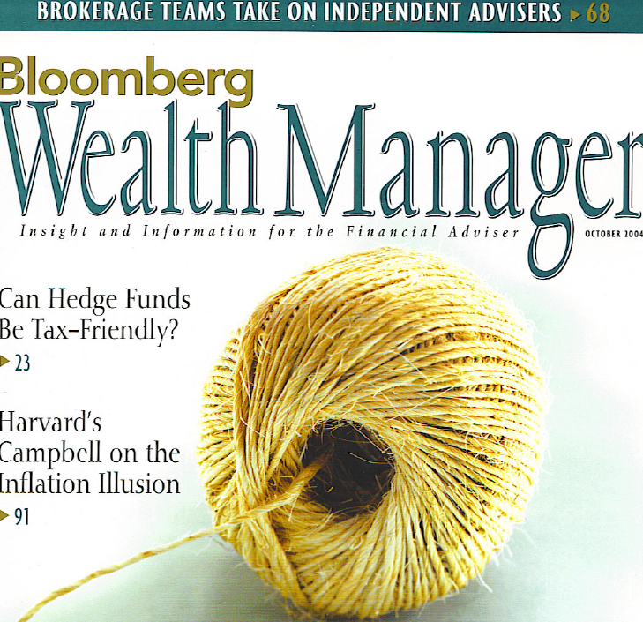
MARKET MATTERS
HEDGE FUND REGULATION

THE PROS AND CONS OF REQUIRING SEC REGISTRATION FOR HEDGE FUND MANAGERS
that's sidestepped registration that worries Donaldson and the two other commissioners who favor regulation. They claim that compiling basic information on all hedge funds will help the SEC deal more proactively with the issue of fraud. "The growth in hedge funds has been accompanied by a substantial and troubling growth in the number of our hedge fund fraud enforcement cases," the proposal asserts.

For its part, the MFA has formally taken issue with the SEC's proposal. The trade group and other critics of increased regulation counter that hedge funds are after all designed for wealthy, sophisticated investors, a group that can fend for itself. They claim that SEC resources are better directed at protecting the mass of smaller investors from fraud in, say, mutual funds. Besides, as Cynthia Classman, one of the two SEC commissioners who voted against the proposal, told Bloomberg News in July, 46 hedge fund frauds out of 2,600 enforcement cases in the five years through the end of 2003 are relatively few. Furthermore, the critics claim, the SEC and other government agencies already have the power to investigate federal securities violations. Granted, said Donaldson in Senate testimony. But under existing rules, the SEC can only go in once fraud has been committed. "It's like arriving at the scene of the accident after it's happened," he explained.
Should the roughly 7,000 U.S. hedge fund managers, who most market watchers expect will soon be controlling $1 trillion in assets, be required to register with the Securities and Exchange Commission? Opinion among managers—and among regulators—is mixed. "If you look at the hedge fund industry, it's really bifurcated on this issue," says John Kelly, a board member of the industry's trade group, the Managed Funds Association (MFA), and chief executive officer at Man Investments in Chicago, a leading manager of hedge funds. "There are a number of managers that just don't want the administrative burden." Yet others say that registered hedge funds are a good idea, that registration provides a competitive edge when marketing to investors.
The SEC commissioners are similarly divided. Although on July 14 the commission formally proposed that virtually every hedge fund manager register under the Investment Advisers Act of 1940, the vote was
close—three to two.
SEC Chairman William Donaldson, a veteran Wall Street executive who cofounded the investment bank Donaldson Lufkin & Jenrette and who cast the tie-breaking vote in favor of regulation, is on record saying that he views protecting investors as the SEC's primary mandate. Such protection requires more information from hedge fund managers than what is currently available—information that the SEC can reasonably acquire only by mandating that hedge fund managers become registered advisers and fill out Form ADV. "Here's a $1 trillion slice [of investment assets] that we don't have a right to go look at," Donald-son told the Senate the day after the vote. "This is an important loophole we need to fill."
In truth, the loophole is already half filled. Nearly 50 percent of all hedge fund advisers in the country have voluntarily registered, according to the SEC's September 2003 staff report on hedge funds. But it's the other half
Requiring all hedge fund managers to become registered investment advisers would be a first step toward
bloomberg wealth manager 99

