Portfolio Diversification:
Traditional-Alternative Core with Satellite Tactical Allocations

December 2, 2013
Authored by: Kipley Lytel, CFA
Diverse portfolios ensure at least some investments will be in the capital market's top performing category at any given time, regardless of what's hot and what's a flop. And you will never be fully invested in the year's losers. Different securities tend to perform uniquely at any point of time and with a diverse mix of assets, a portfolio will be less likely to suffer extreme losses that would impact concentrated portfolios. At the most basic level it is simple practice of not putting all your eggs in one basket; yet, at the root of diversification is a concept called correlation, which is a measure of how the returns of investment asset classes move together. Studies suggest when you collect different assets that have low correlations in a portfolio, you may be able to get more return while taking on the same level of risk, or the same returns with less risk.
For instance, historically large-cap U.S. stocks and long-term government bonds have been considered two diverse asset classes given they have had a low correlation of 0.06¹. However, there has been recent research suggesting that after the 2008 market upheaval, low correlation attributes of asset classes in diversified portfolios have since decreased. It is also important to realize that during periods of financial distress, correlations tend to move in the same direction toward 1.00 (more correlated). Even in the throes of these two trends, there remains substantial portfolio investment merit to asset class diversity of low correlated holdings.
Our firm's approach is to develop a diverse Core Portfolio of both traditional and alternative asset classes, which constitute about 70% of our holdings, of which the components include: domestic/international equities, mutual hedge funds, alternative funds, domestic/international bonds and multiple asset classes. The factors that drive the allocations are dictated by relative valuation, directional rate expectations, inflation, volatility, and level of economic growth/stability, among other considerations. See the matrix below.
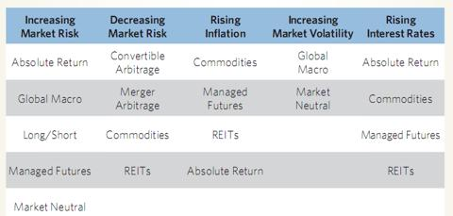
We will discuss examples of different specific holdings later in the article, but our largest current asset class allocations are to domestic/international equities and multiple strategy.
Turning to our Satellite Portfolio with a 30% weighting, we then layer in more tactical allocations for the lower correlated, non-traditional assets of the portfolio, which include: high yield bonds, convertible bonds, preferred stock, Master Limited Partnership "MLP," farm land (& timber), currency and precious metals. Similar to our Core Portfolio, based on our firm's outlook of asset classes, we adjust allocation to overweight or underweight, but also there is higher trade frequency for Satellite positions given these tactical components are often characterized with lower correlation and higher volatility, which require more active adjustments for revision of the mean. In other words, as certain asset classes move to over-bought on a historical basis without a rational catalyst (overvalued), then we profit take and reallocate to the other asset classes that may be over-sold (undervalued).
A correlation matrix illustrates the type of directional price movement behavior that can be expected from different asset classes. The closer the correlation gets to 1 the more two assets (or asset classes) move in tandem. In turn, the more the correlation gets to negative 1, the more the two assets move in opposing directions.
)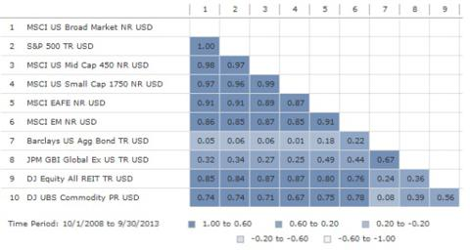
According to a study by Professor Craig Israelsen "The Benefits Of Low Correlation" with the five-asset portfolio - large-cap U.S. stocks, small-cap U.S. stocks, non-U.S. stocks, bonds and cash - which is about what the typical target date portfolio, he got a 10% internal rate of return while sustaining retirement withdrawals. The worst one-year drawdown since 1970-2007 was 17%. However, when he added REITs and commodities, the internal rate of return rose to 11.3%, yet the worst one-year drawdown fell to 10%. Israelsen's study found that by adding commodity and real estate's low correlations, drawdown risk was ultimately reduced by over 40%.
Looking back over three decades, the correlation of both high-yield bonds and convertible bonds with investment-grade bonds have been about 0.30 and 0.07, respectively, and 0.55 and 0.85, respectively, with US stocks. Although convertible bonds still had a reasonably high correlation with US stocks, precious metals have had a historical negative correlation to stocks and farm land has had only about 0.25 correlation. Meanwhile, MLP's correlation has been in the 0.5-0.65 range for US stocks.
Overall, we believe a more robust asset allocation approach is warranted to adjust to 'risk-off' and 'risk-on' paradigm that is indicative of a more correlated asset class world, having greater geopolitical risk and interdependency between global market counterparts. We also believe that when the capital markets move to 'risk-off,' lower correlated asset classes will help mitigate portfolio downside risk. This does not suggest investors should not have high conviction in certain asset classes, nor does it imply that investors should blindly hold certain assets with low-return outlook for the sole purpose of low correlation. Rather, investment conviction should drive the allocation of what asset classes to overweight in a portfolio or perhaps, at times, eliminate from the portfolio. For example, we have moved in and out of our precious metals positions while sharply adjusted commodities along and MLPs over time. We have moved to more flexible, unconstrained bond funds and shortened duration this year, all of which insulated our portfolios from price weakness in this asset class.
In closing, in an effort to put the meat in the bone, provided below are specific examples of fund allocations for different asset classes. Inasmuch as these holdings have a role in a portfolio, we don't hold all these securities currently (but hold most of the mutual funds) and this is a very abbreviated version of a typical portfolio, which would hold substantially more securities and funds. We also tend to hold more of the mutual fund versions for the mutual hedge funds, alternative asset, emerging market bond, convertible bond and high yield. The ticker symbols provided fit the asset class criteria, but are not intended to duplicate the exact strategy between ETFs and mutual funds. It is noteworthy that we hold individual stocks and bonds, which don't fit this matrix, and we also have historically held much higher bond allocation than we currently allocate in this environment.
CORE PORTFOLIO* (70% Portfolio) | ETFs | Mutual Funds
Mutual Hedge Funds (L/S) | (QEH) | MFLDX, DIAMX
Alternative Asset | (MNA) | GATEX, GTSOX
Domestic/Int'l Equity (Large Weighting) | (CVY)(SDY) | GHUAX, ICMBX
Multiple Strategy (Large Weighting) | (GYLD) | GRSPX, PRPFX
US Fixed Income (Moderate Weighting) | (BSV)(BKLN) | AVEFX, PYTRX
Emerging Market Debt | (VWOB) (PFEM) | PYEWX
Global/Int'l Debt | (BWZ) | HABDX
SATELLITE PORTFOLIO (30% Portfolio) | ETFs | Mutual Funds
Preferred Shares | (PFF) | CPXAX
High Yield | (HYLD) (NSL) | MWHYX, SFHYX
Convertible Bonds | (CWB) | VCVSX, PCVDX
Hard Assets (REIT,MLP, Commodity, Metals) | (SCHH) (AMLP) | GHAAX, EGLAX
S-Term Trade (F/X, Energy, Volatility) | (XOP) | MERKX
*All Mutual Funds are Load Waived within our Charles Schwab Institutional Platform.
¹(2012 Ibbotson Stocks, Bonds, Bills, and Inflation Classic Yearbook Morningstar)

